# Mingol Condo Website

We now have a website for our home owners association and it is chocked full of information for residence and others.

To access the site, open your browser and go to the following location:

[www.mingolcondoassociation.com](http://www.mingolcondoassociation.com)

You should see the page below.

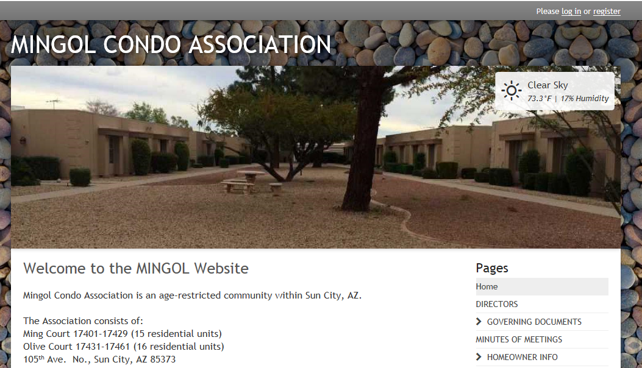

You can now see all of the web content by selecting the headings on the right side of the page.

Those headings that show a padlock next to them, such as , can only be accessed by registered users. These pages include private contact and financial information.

To register on the site, click on the ‘Register’ link in the upper, right corner of the page.

Follow the prompts and select a password that only you will know.

At the completion of you registration the Site Administrator will approve or decline the access and when approved, you will receive an email informing you of your status.

If approved, you can then view the site as anyone can, or log into the site using your registered credentials.

We urge you to explore the site and please inform us, through the Contact Us page, of any errors you find.

Enjoy!